The water content of honey is an important quality criterion as it determines the capability of honey to remain stable and to resist spoilage by yeast fermentation: the higher the moisture, the higher the probability that honey will ferment upon storage. For honey to remain fit for consumption, its moisture content must not exceed the permitted limit of 21 % set by the International Honey Commission (IHC).

The moisture content of honey (or conversely the dry matter content) is determined by measuring the refractive index using a refractometer at 20 °C. The refractive index proportionally decreases with increasing water content. Newer refractometers provide a direct reading of the moisture content of the honey sample. To ensure an accurate refractive index measurement, temperature control is required. Most refractometers have automatic temperature compensation; refractometers without temperature compensation come with a reference chart to convert the reading. In this case, it is necessary to take the temperature of the honey sample and use the correction table to get the right value.

Refractometers do not tolerate immersion in water or being held under a tap for cleaning. They should not be touched with clammy or wet hands either!

### Refractometer design

1. Prism flap
2. Prism
3. 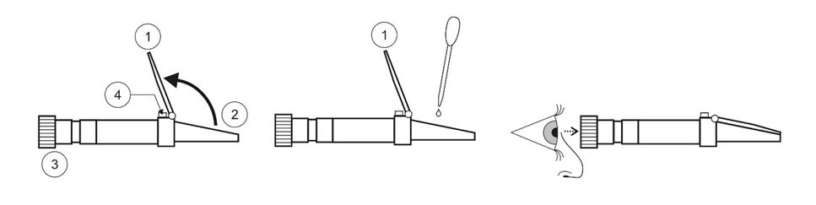Eyepiece

Fig. 1: How to use a refractometer

1. Calibration adjustment screw

## Task

### Calibration

Before you use a refractometer, it needs to be calibrated. Most refractometers are calibrated by using a sample of distilled water.

1. Lift the flap and add a few drops of distilled water. Close the flap and allow the water to spread across the prism. Make sure there are no bubbles.
2. Look through the eyepiece while aiming the instrument towards a source of direct light (do not look directly at the light with the naked eye). Rotate the dial near the eyepiece to focus the scale until you can read it clearly.
3. The calibration screw will let you adjust the zero setting. What you want to do now is adjust the refractometer so it reads zero with distilled water in it. This may take a few tries.

### Experiment

Equipment pipette, non-abrasive cloths

Chemicals distilled water, various samples of honey, ethanol (for cleaning the prism)

Dangers no dangers

1. Prepare samples of two types of shop-bought forest honey and flower honey, respectively. In addition, collect two honey samples (fully capped cell, unsealed cell) from your eHive.
2. Use a glass rod to place a drop of the first honey sample on the prism and close the flap. The honey needs to be liquid and must not contain any crystals.
3. Hold the refractometer up towards an area of natural light, look though the eye piece, and read the moisture content value at the point where the contrast line crosses the scale. If there is no sharp contrast line, repeat the procedure. If the measured value lies between two graduations, estimate the water content of the sample.
4. Repeat the measurement to confirm the measured value.
5. Repeat the above steps for each honey sample.
6. Clean the refractometer with distilled water and dry with a soft non-abrasive cloth. Hand it back to your teacher.

### Measured Values

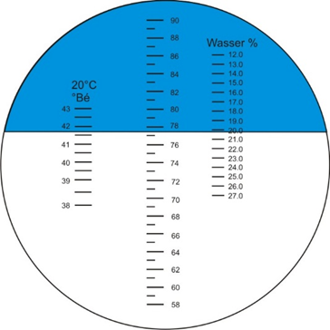

Fig. 2: Reading the water content value from a refractometer scale (graduation on the right hand side)

1. Note down the measured values in the table below.

|  |  |  |
| --- | --- | --- |
|  | Measured value 1 | Measured value 2 |
| eHive honey (“fully capped“) |  |  |
| eHive honey (“unsealed”) |  |  |
| Flower honey 1 |  |  |
| Flower honey 2 |  |  |
| Forest honey 1 |  |  |
| Forest honey 2 |  |  |

### Analysis

1. Propose an explanation for the differences you may observe between the measured values.

Hint: Honey is to be harvested only when it is mature enough. Normally a frame of honey three-quarters capped with wax can be considered for removal. One test to determine the ripeness of honey is to hold an uncapped comb containing honey on its side and to give it a gentle shake. If honey leaks from the cells, it isn’t cured and shouldn’t be extracted. The beekeeper should wait until the ripening process is completed.

1. Explain which problems may occur if honey is harvested with a moisture content too high.
2. Discuss the results with your neighbour and write them down.

For the quicker pupils

1. Form a hypothesis as to why honey with a moisture content of less than 21 % keeps „forever“ while honey with a higher water content is prone to spoilage.

## Literature

Bogdanov, S., Martin, P., Lüllmann, C.: Harmonised methods of the European Honey Commission. Apidologie (1997) Extra issue, 1-59.

Bader, H.J., Flint, A.: Beiträge zur Didaktik der Chemie, Bd. 2, Verlag Deutsch (1999)

Belitz, H., Grosch, W.: Lehrbuch der Lebensmittelchemie, Springer Verlag (1982)

Horn, H., Lüllmann, C.: Das große Honigbuch, Ehrenwirth Verlag (1992)

Lipp, J.: Handbuch der Bienenkunde – Der Honig, Ulmer Verlag (1994)

Schalko, W., Stiedl, W.: Der Honig im Schulunterricht, Workshop bei der Fortbildungswoche für Physik- und ChemielehrerInnen, Wien (2002)